**Databases Laboratory Work Nr1**

**Title: Instalarea si configurarea SQL SERVER 2017**

**Sarcini practice:**

**1:**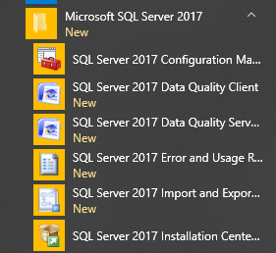

**2:**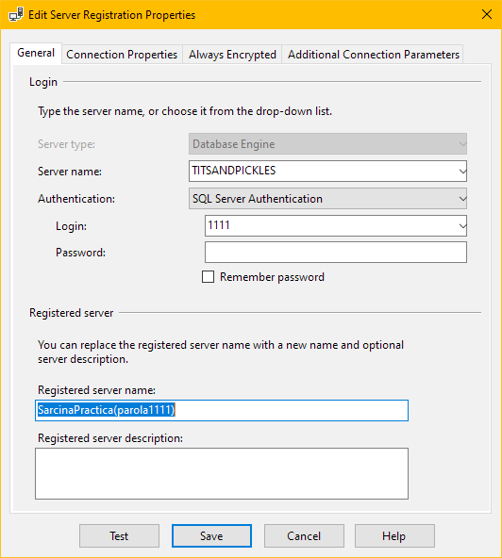

**3:a)**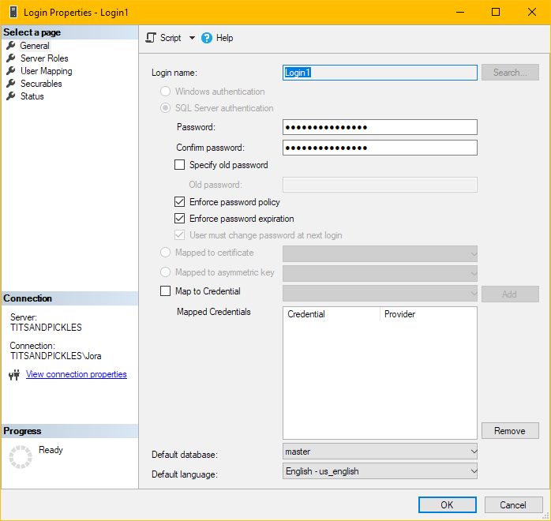

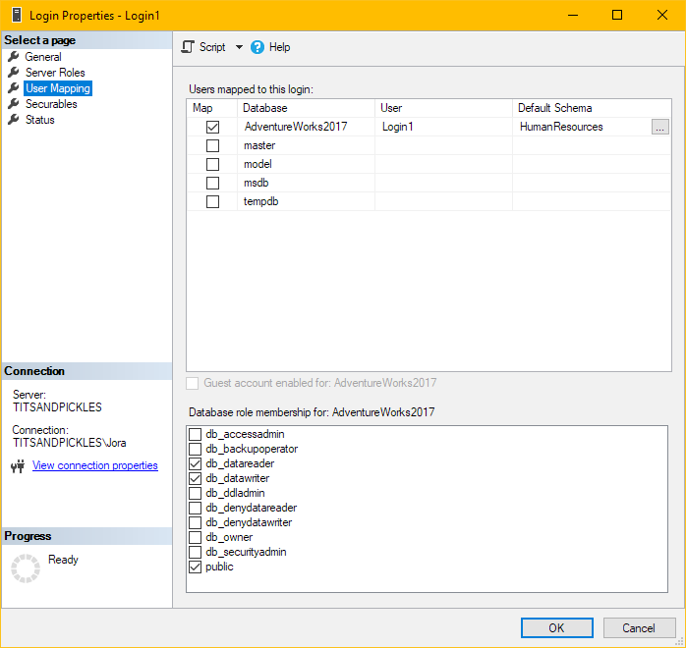

**b)**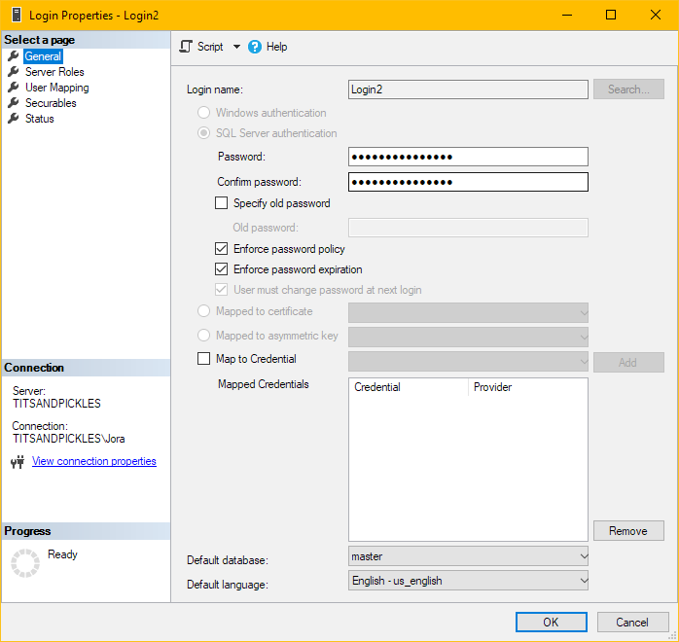



**c)**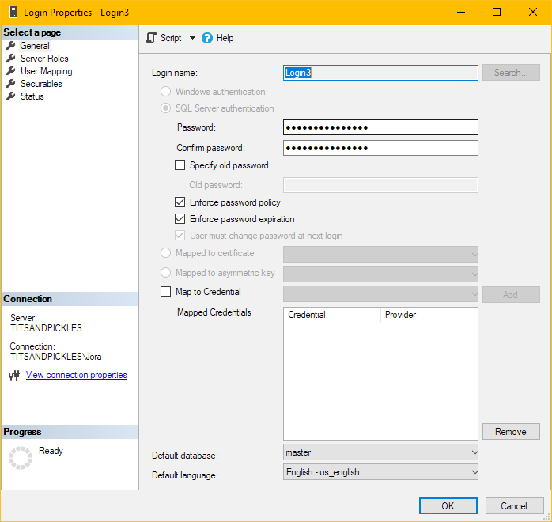



**Conclusion: I have installed and configured successfully SQL Server 2017 with the help of the book by doing everything step by step, it was a very straight forward approach and it wasn’t difficult at all.**